Psalm 23 Common Worship Chant: John Goss

Chant on a single line of music:



Or, on two lines of music for copying into narrow columns:

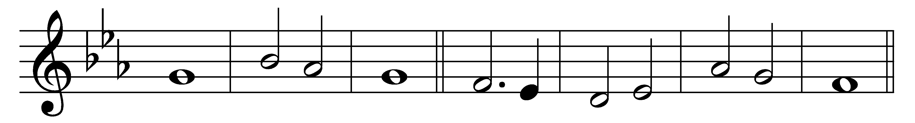

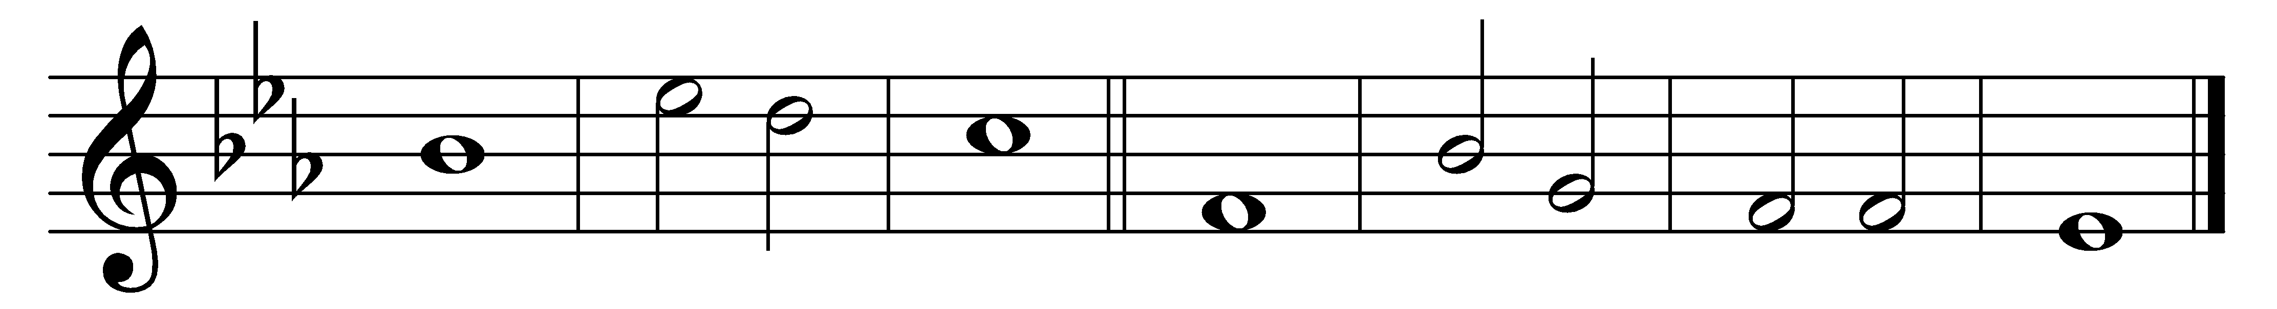

The | Lord is· my | shepherd;

therefore | can I | lack | nothing.

2 He makes me lie | down in· green | pastures

and | leads me· be-| side still | waters.

3 He shall re-| fresh my | soul

and guide me in the paths of righteousness | for his | name’s | sake.

4 Though I walk through the valley of the shadow of death, I will | fear no | evil;

for you are with me; your | rod and· your | staff, they | comfort me.

5 You spread a table before me in the presence of | those who | trouble me;

you have anointed my head with | oil· and my | cup shall· be | full.

6 Surely goodness and loving mercy shall follow me all the | days of· my | life,

and I will dwell in the | house· of the | Lord for | ever.

Words taken from Common Worship © The Archbishops’ Council 2000.